Wavelabs’ Lab setup consists of n nodes numbered from 0 to n - 1 connected by undirected node-to-node connections forming a network where connections[i] = [ai, bi] represents a connection between nodes ai and bi. Any node can reach other nodes directly or indirectly through the network.
A critical connection is a connection that, if removed, will make some nodes unable to reach some other node.
As a network engineer, it's important to maintain a list of critical connections. Return all critical connections in the network in any order.
Example:
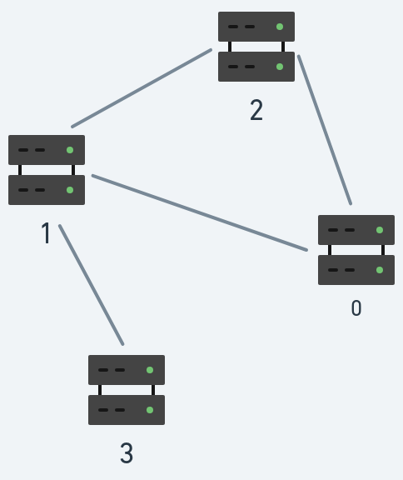
Input: n = 4, connections = [[0,1],[1,2],[2,0],[1,3]]
Output: [[1,3]]
Explanation: [[3,1]] is also accepted.

Constraints:
- 2 <= n <= 105
- n - 1 <= connections.length <= 105
- 0 <= ai, bi <= n - 1
- ai != bi
- There are no repeated connections.
Solve the questions in C/C++/ Go lang only No other Language

ANSWER :

class Solution {
private:
int timer = 1;
private:
void dfs(int node,int parent,vector<int> &vis,vector<int> adj[],int tin[],int low[],vector<vector<int>> &bridges){
vis[node] = 1;
tin[node] = low[node] = timer;
timer++;
for(auto it: adj[node]){
if(it == parent) continue;
if(vis[it] == 0){
dfs(it,node,vis,adj,tin,low,bridges);
low[node] = min(low[node],low[it]);
//node -- it
if(low[it] > tin[node]){
bridges.push_back({it,node});
}
}
else
{
low[node] = min(low[node],low[it]);
}
}
}

public:
vector<vector<int>> criticalConnections(int n, vector<vector<int>>& connections) {
vector<int> adj[n];
for(auto it: connections){
adj[it[0]].push_back(it[1]);
adj[it[1]].push_back(it[0]);
}
vector<int> vis(n,0);
int tin[n];
int low[n];
vector<vector<int>> bridges;
dfs(0,-1,vis,adj,tin,low,bridges);

return bridges;
}
};

